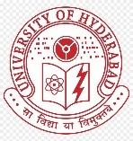 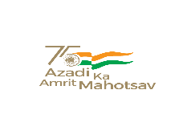 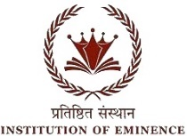

**BHARAT KA AMRIT MAHOTSAV**

UNIVERSITY OF HYDERABAD

SCHOOL OF COMPUTER AND INFORMATION SCIENCE

Collaboration with O/o Dean Student Welfare & O/o Chief Warden

Cordially invites you to Technical Sessions of Two days National Seminar on “BAM-2022“

Organized on 7th & 8th April 2022

Technical Session 3

“Social and cultural aspects of designing AI systems in context of Sanatana Dharma”

**8th****April 9:30am to 11:15am** **Venue:** **New Seminar Hall, SCIS**

|  |  |  |
| --- | --- | --- |
| **Session Chair** | Prof. R. P. Lal |  |
| **Rapporteur** | Mr. Yashashvi R P |  |
| **Plenary speech by** | Prof. Hrushikesha Mohanty,  Former VC of KIITS, Bhuvaneshwar | **9:30 – 10:00** |
| **Student paper presentation** | | |
| **Mr. Shubham Misra** | On better experiencing Slokas using recitation and local-language translation | **10:00–10:15** |
| **Mr. Jatin Dehmiwal** | On end-user software for increasing accessibility of books to Indian masses | **10:15–10:30** |
| **Ms. Chhanda Saha** | ML-supported IoT approaches for women  security | **10:30-10:45** |
| **Mr. Souvik Ghosh** | Computer vision-based software demo for women safety and emergency response | **10:45-11:00** |
| **Mr. Vivek Kumar** | Intelligent “assistance” systems for elderly people in modern nuclear society | **11:00-11:15** |